# Packet Sniffing And Firewall Assignment

Contributor: Junda Lou, Hao Zheng

## 1. Packet Sniffing

Problem 1: Please use your own words to describe the sequence of the library calls that are essential for sniffer programs. This is meant to be a summary, not detailed explanation like the one in the tutorial.

1. **Setting up device**

We started by setting up which interface we want to sniff on(e.g. etho0, x11, etc). We can either do it by using a string in the code for sniffer or sniffer decideds the inferface itself by picking up an active interface automatically.

1. **Initialize Sniffing**

After setting up a device for sniffing, sniffer initialize pcap and tell it to sniff on a particular device called as a session. We can even sniff on multiple devices or interfaces by managing different sessions for each device.

1. **Traffic Filtering**

For every session of sniffing we have to define the specific rule. For example, if we want to sniff HTTP traffic on a specific interface of a computer, we need to sniff TCP port 80(HTTP traffic uses port 80), we write our requirement in filter string and then complie it to apply the rule. We can also use blank filter to sniff all packets and analyze all fields.

1. **Execution sniffing**

Here comes the execution part where sniffer is finally exectued. In this step, pcap waited for receiving any number of packets we want. Upon receiving applied the specific rules that were defined in previous step. We can either display the packets imeediately or save them in a file for future record.

1. **Ending Session**

After we are done with the requirements of sniffing, we close our seesion and sniffing is complete.

Problem 2: Why do you need the root privilege to run sniffex? Where does the program fail if executed without the root privilege?

pcap_loopupdev() function nneds root access because it wants to access network interfaces. It is impossible without root access to execute it. Sniffer need raw sockets that allow direct sending of packets by the applications. And we need to be a root to create raw socket.

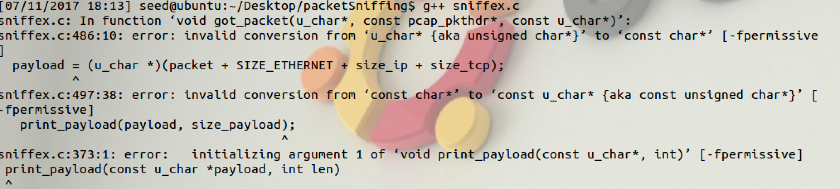

Problem 3: Please turn on and turn off the promiscuous mode in the sniffer program. Can you demonstrate the difference when this mode is on and off? Please describe how you demonstrate this.

In non-promiscuous sniffing, a host is sniffing only traffic that is directly related to it. Only traffic to, from, or routed throught the host will be picked up by the sniffer. Promiscuous mode, on the other hand, sniffs all traffic on the wire.

I changed source code of sniffex in order to change promiscuous mode by passing different arguments.

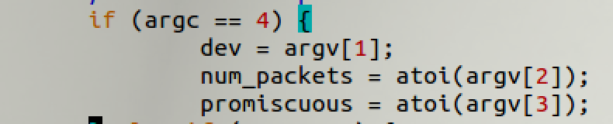

To demonstration let’s consider a scenario where we have two virtual machines, say A (10.0.2.5) and B (10.0.2.4), with sniffex running on B and A tries to ping B.

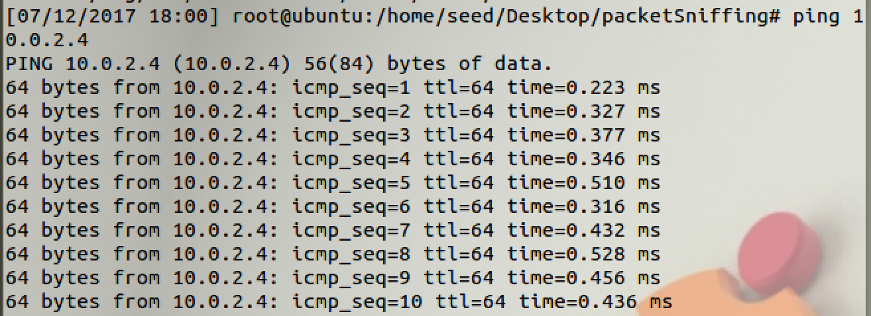

In non promiscuous mode I found that no packet in sniffed at B other than those with distination address of B (10.0.2.4) as shown below.

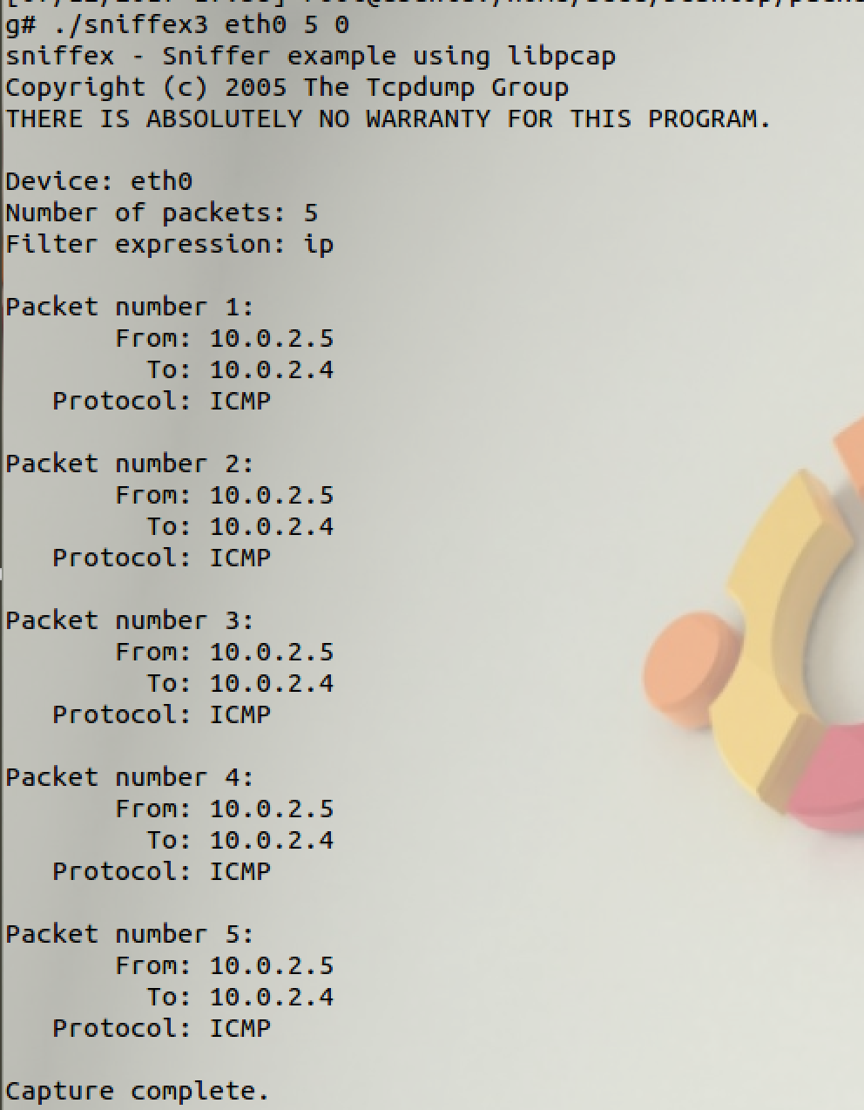

Now for the promiscuous mode, when I did same that is pinged B from A, I could see some packets being received which destination isn’t B. This could be clear from the pictures.

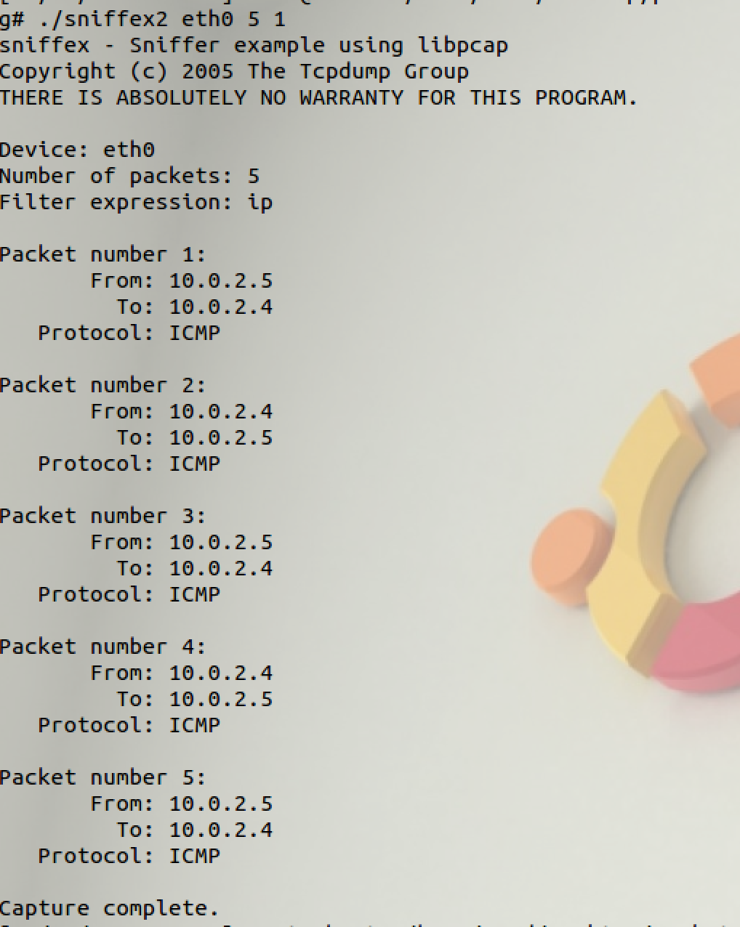

Problem 4: Please write filter expressions to capture each of the followings. In your assignment reports, you need to include screendumps to show the results of applying each of these filters

* Capture the ICMP packets between two specific hosts.

To Capture the ICMP packets between two specific hosts I used following filter expression.



Here my sniffer was running on the machine A with IP = 10.0.2.4, and Machine B (10.0.2.5) pinged mechine A, and I found packets been captured by the sniffer.

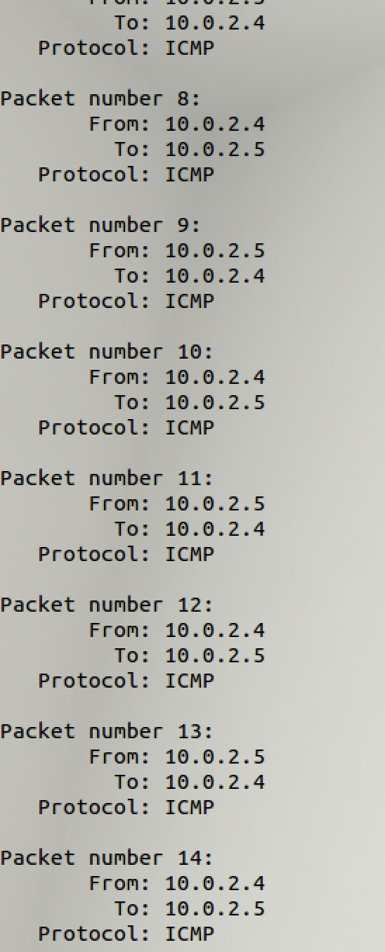

* Capture the TCP packets that have a destination port range from to port 10-100.

To capture Packets within TCP port range from 10-100, I applied following filter:

**tcp dst portrange 10-100**



And telnet machine B (10.0.2.4) on machine A (10.0.2.5)

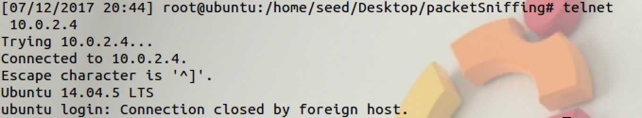

Sniffer running on 10.0.2.4 caught the packet sent from 10.0.2.5 to 10.0.2.4 using telnet on port 23. But it did not caught packets when destination prot was higher than 100.

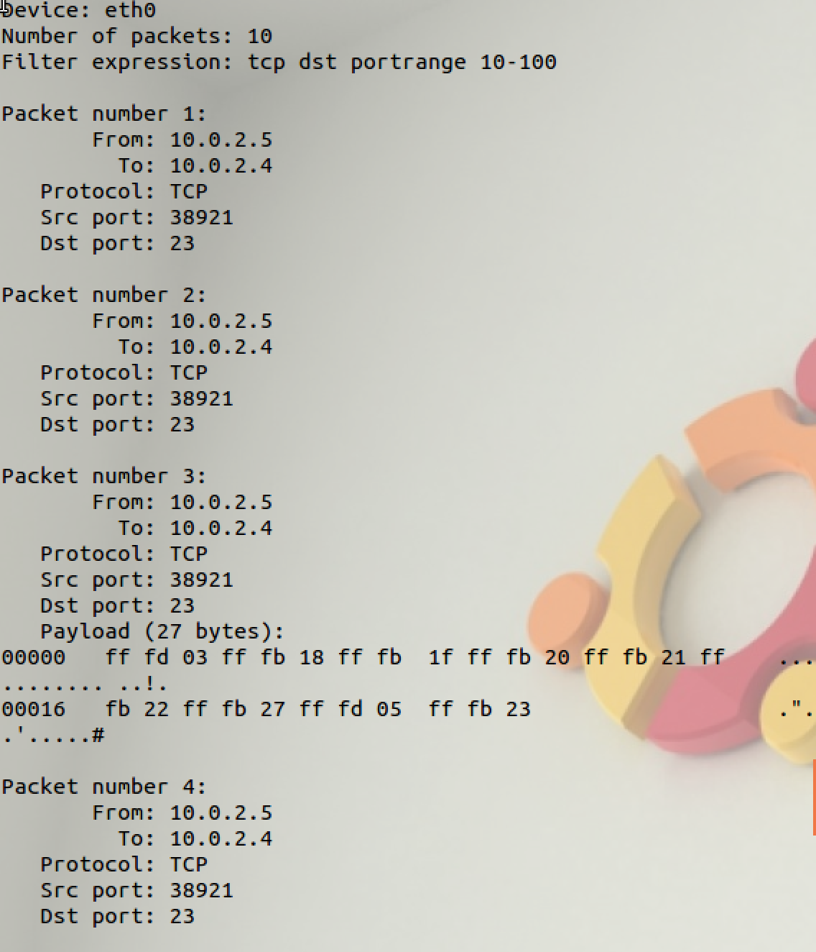

Problem 5: Please show how you can use sniffex to capture the password when somebody is using telnet on the network that you are monitoring. You may need to modify the sniffex.c a little bit if needed. You also need to start the telnetd server on your VM. If you are using our pre-built VM, the telnetd server is already installed; just type the following command to start it.

Here we take two machines say A (10.0.2.5) and B (10.0.2.4), when A try to telnet to B on port 23, B asked A for login credentials. After conneting B, machine A need to enters login and password they can be captured with the help of a sniffer in the Network. Following shows the connecting process:

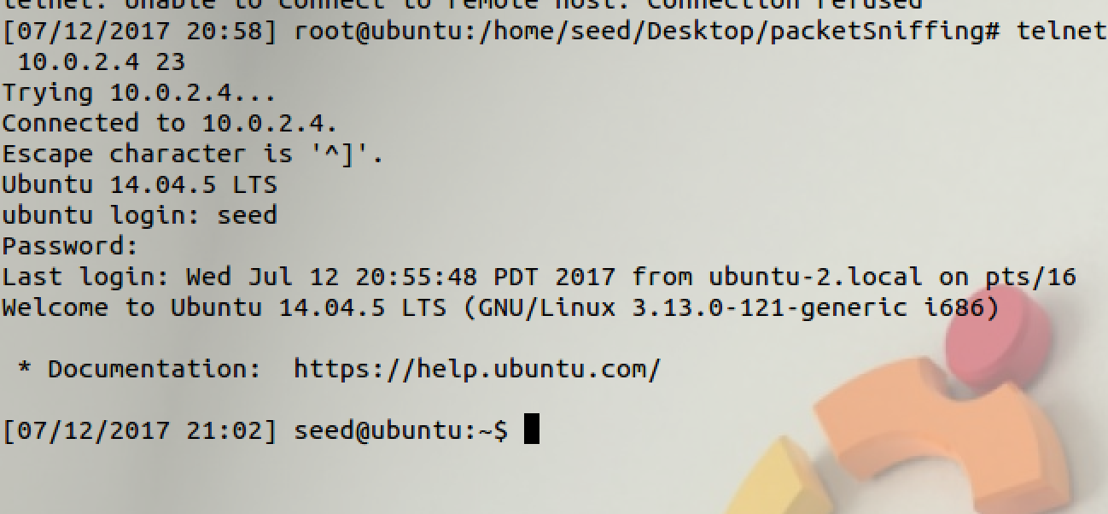

Below figures show that when B asked A to enter password it was sent character by character and was caught by the sniffer in the middle.

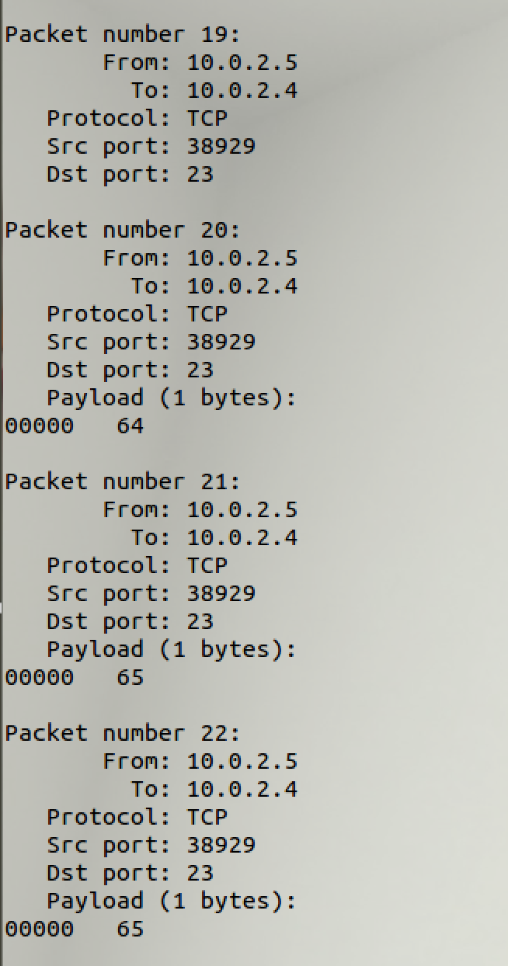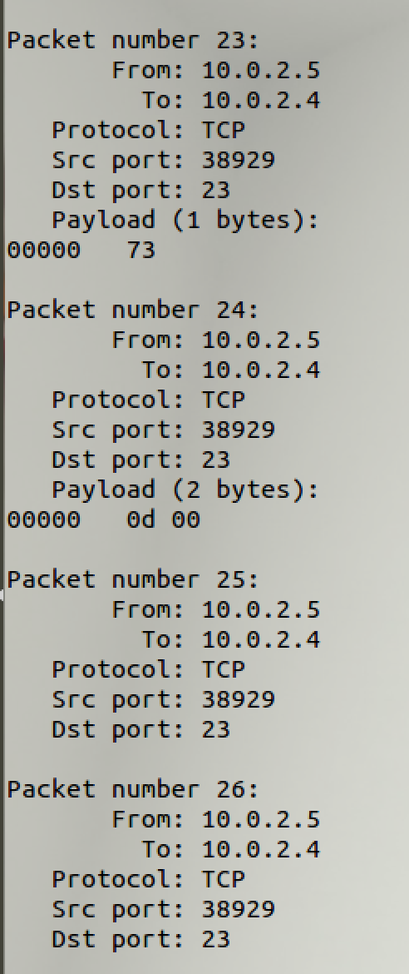

## 2. Firewalls

2.2.

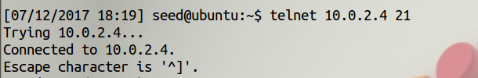

Before enable the Firewall

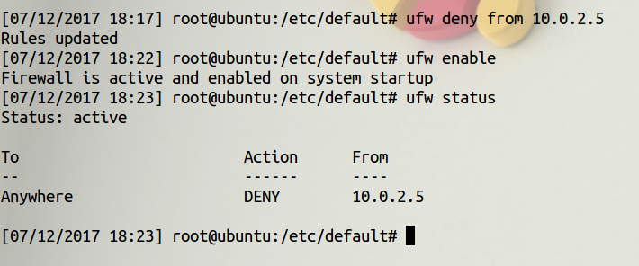

Set the Firewall to block to block traffic from 10.0.2.5, which is the Machine B IP address.

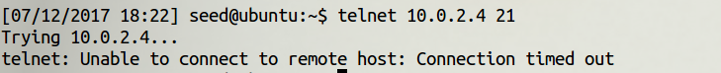

Then it is not able to connect.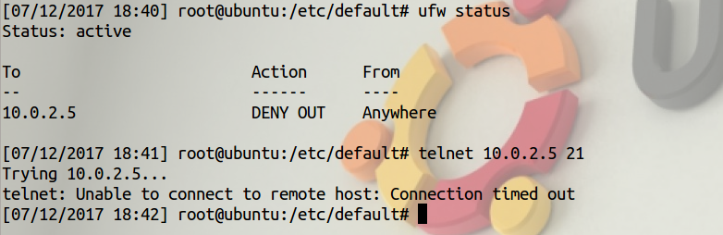

Same for Machine A connecting to Machine B.

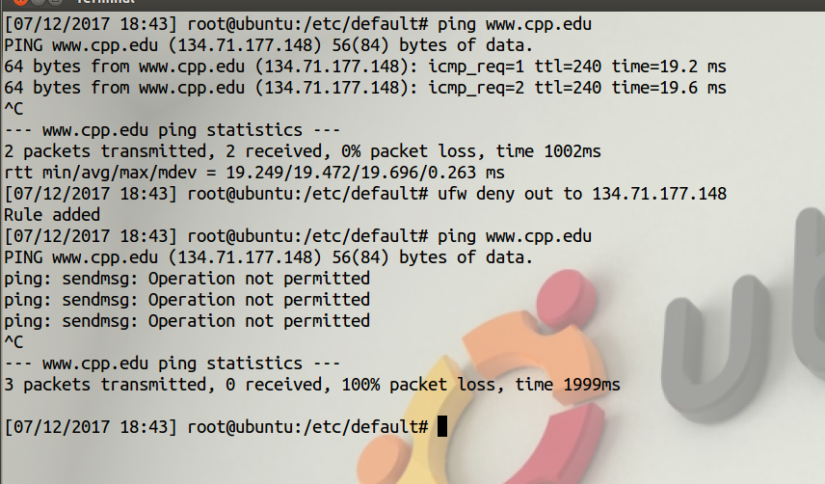

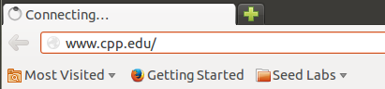

Block visiting external website (cpp.edu)

## 3. Evading Egress Filtering

2.3

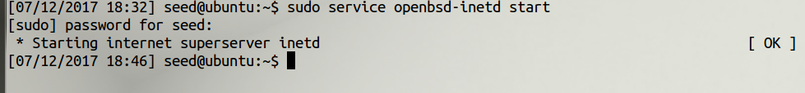

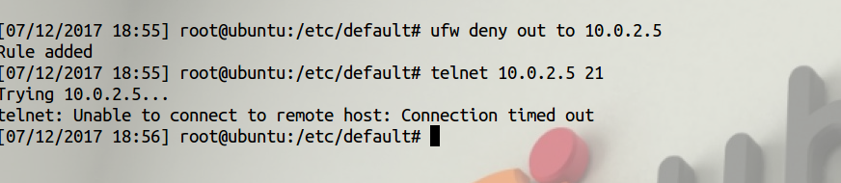

Traffic blocked (same as 2.2)

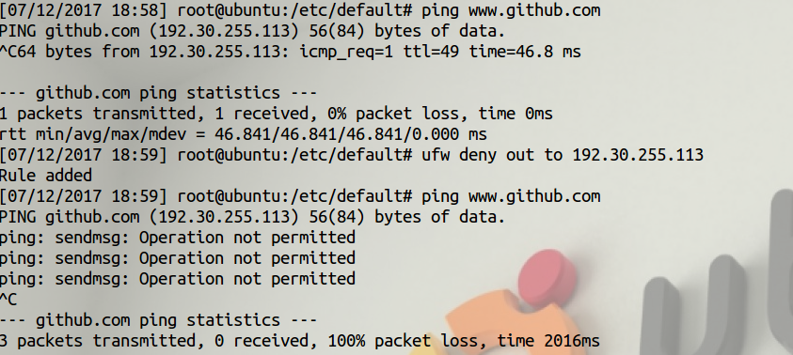

Block traffic to Github

2.3a

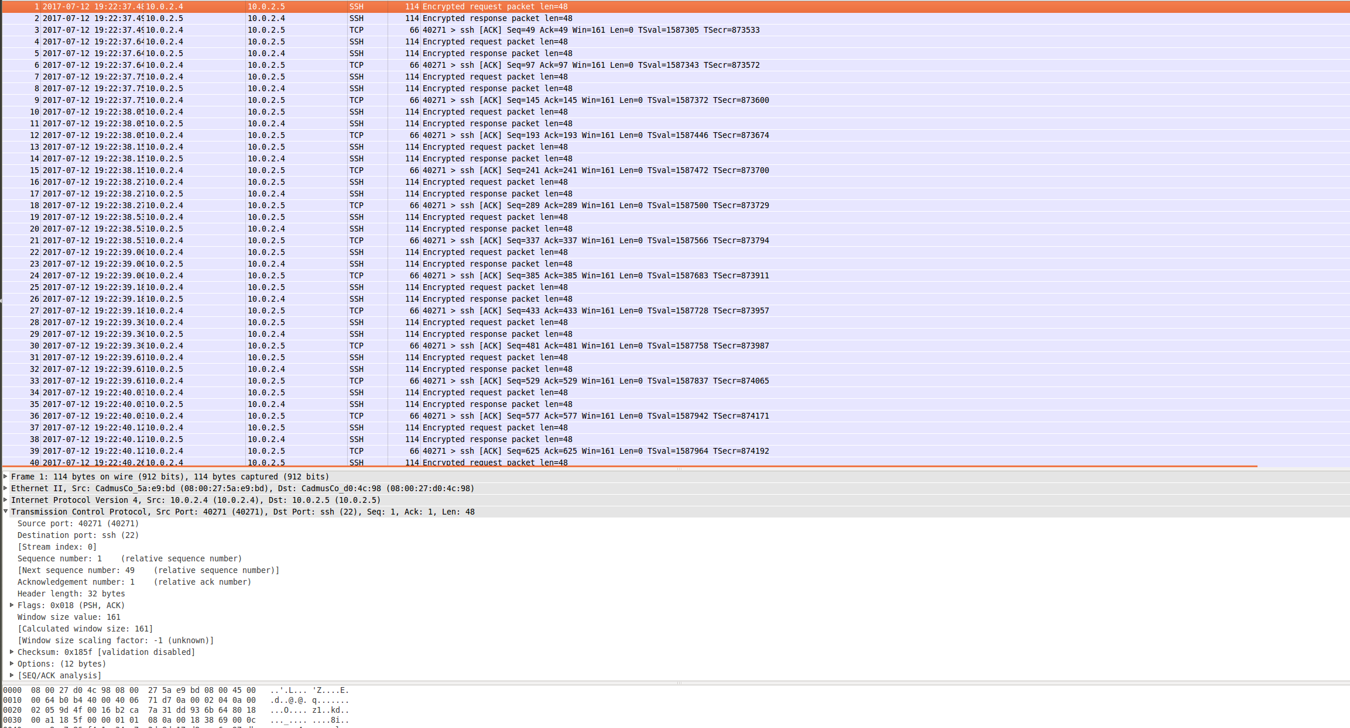

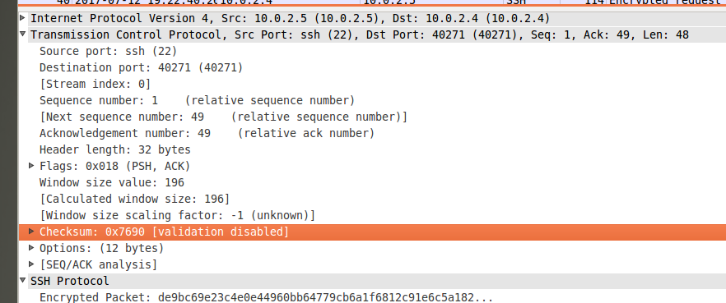



SSH establish a tunnel between two machines, and transfer directly transfer packets that are encrypted.

2.3b



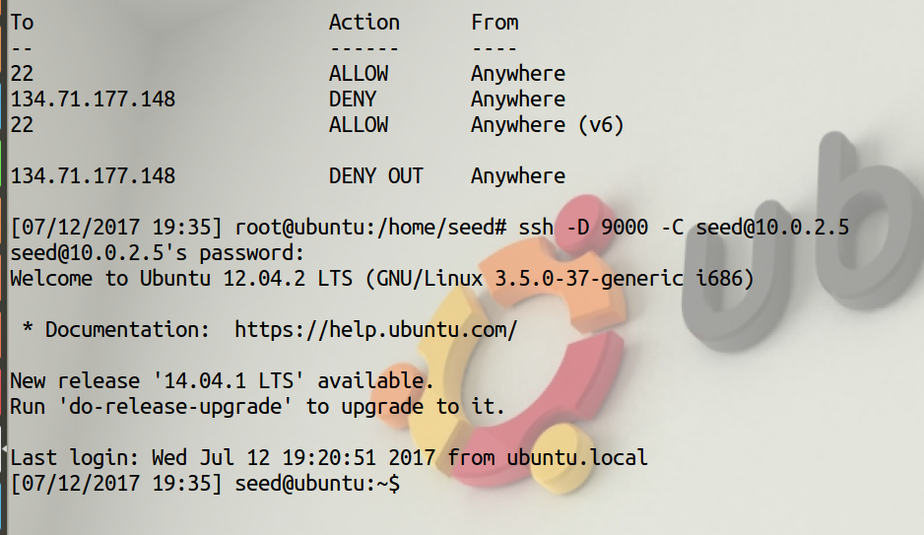

Machine A can visit cpp.edu via ssh to Machine B even though the traffic is blocked from Machine A.

After close the ssh tunnel, Machine A cannot connect to cpp.edu anymore.

However, establish the tunnel again, A can visit cpp.edu.

## 

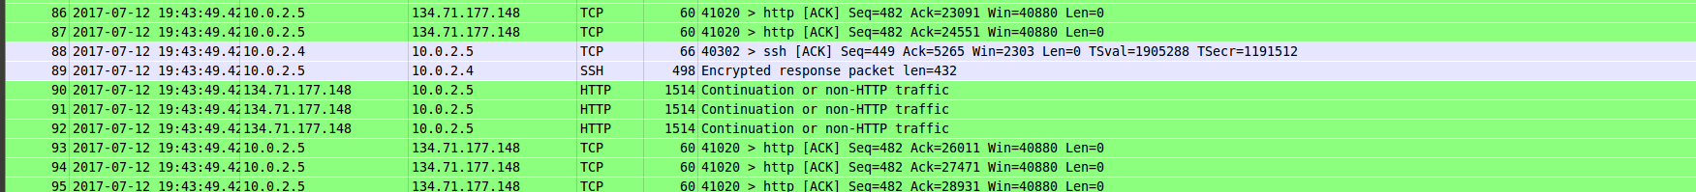

Via SSH, Machine A(10.0.2.4) is connected to Machine B(10.0.2.5) via ssh tunnel. When A wants to visit cpp.edu, B will send a request to cpp.edu(134.71.177.148). Cpp.edu responds to B, and B directly forwards it to A via ssh.

SSH cannot be established if the port 22 is blocked.

Dynamic Port Forwarding will transfer data in the series of ssh client, ssh tunnel(connection), and destination server.

## 4. Web Proxy (Application Firewall)

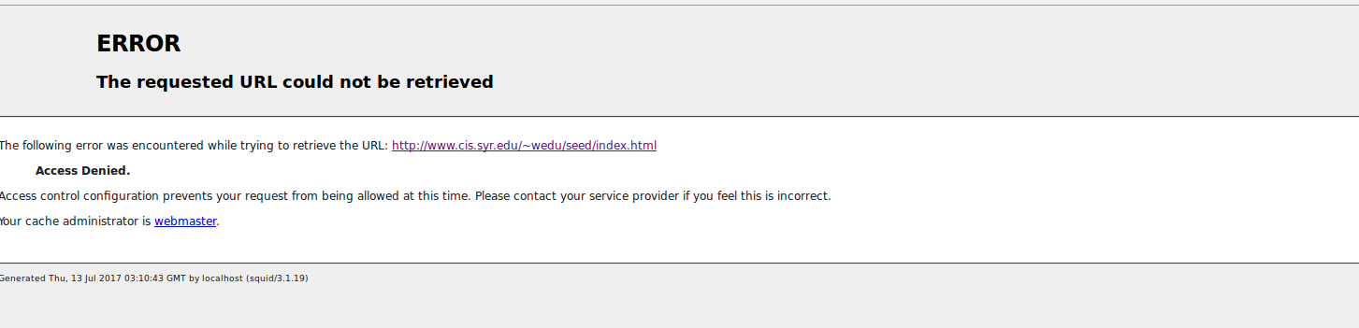

Http_access: deny all is by default in squid

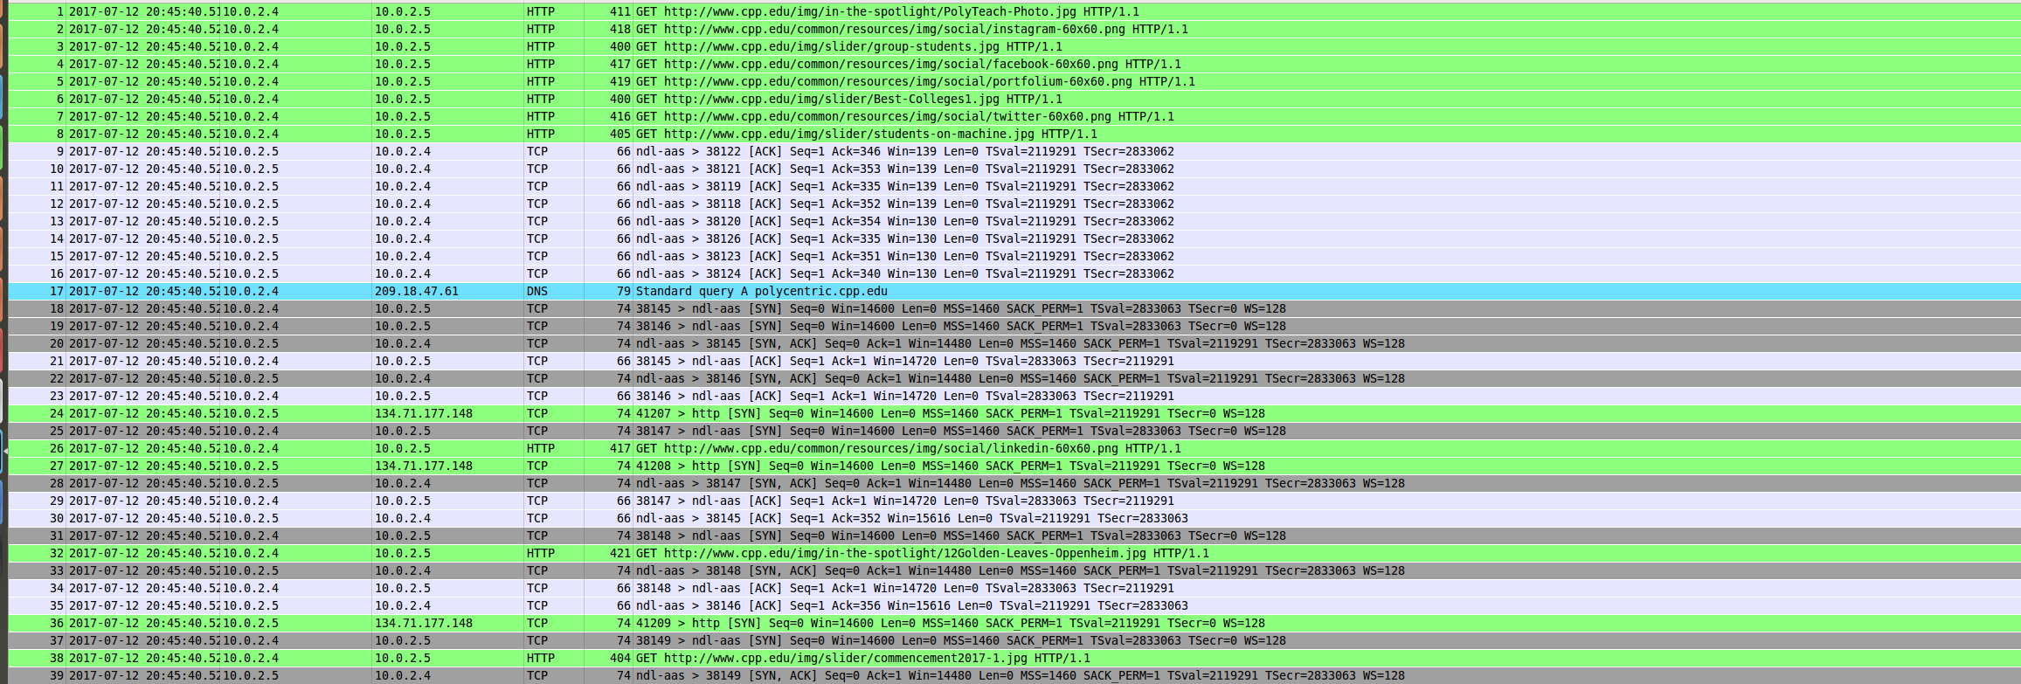

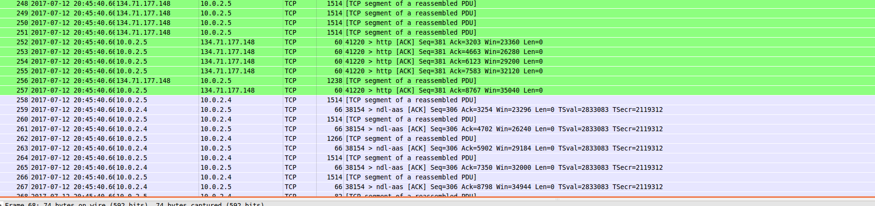

Although cpp.edu is blocked from direct access from A, FireFox uses B as a proxy server, which let A sends the GET request to B, and B will interact with cpp.edu, get the result page, forward back to A.



By only allowing google.com, A can only visit google.com.

If the port 3128 is block, simply change the port number and restart squid3 server, then the proxy can run properly again.

